User guidance for riparian zone science-management relationships

Urbanič, Gorazd, Politti Emilio, Alves Maria Helena, Bruen Michael, Bruno Daniel, Di Lonardo Sara, Egozi Roey, González de Tanago Marta, Gültekin Yaşar Selman, Jansson Roland, Kelly-Quinn Mary, Martinez Roberto, Papastergiadou Eva, Rodríguez González Patricia, Šibíková Mária, Šibík Jozef, Dufour Simon

Introduction – A user guidance what for?
This document aims at guiding scientists and managers in the implementation of the solutions for the enhanced riparian zone management. Closer attention to the sustainable management of riparian zones is urgently needed, because they are among the world’s most degraded ecosystems. However, riparian zones are not recognized as separate critical assets and their sustainable management is not sufficiently supported at all levels of decision making related to riparian zones e.g. water management and spatial planning and among all riparian zone stakeholders (Urbanič et al. submitted). The user guidance focuses on the science-management misalignments and possible solutions recognised by riparian zone scientists and managers across Europe and beyond during the COST action “Knowledge conversion for enhancing management of European riparian ecosystems and services (CONVERGES)” activities.
The document is based on and further specifies solutions recognised during the consultation process containing questions about recognised issues in the riparian zone management as well as suggested solutions. Questionnaires were delivered to riparian zone managers and scientists across Europe. Recognised issues and possible solutions were then discussed at the online workshop organised by COST action Converges in February 2021. Finally, possible solutions were ranked through a second questionnaire by managers and scientists from 26 European states and the United States of America. Ranking was done according to their expertise in potential solutions that would contribute most to enhanced management.
The document constitutes guidance and good practice with a case study, when available. It starts with the description of the issue and continues with the explanation of the solution for enhanced riparian zone management and description of how it should be implemented. At the end, it is shown what solutions have already been implemented.
The guidance is specifically addressed towards:
· Researchers/scientists of varied disciplines e.g. biology, forestry, engineering, water management, nature conservation, environmental sciences, energy, agriculture, spatial planning, human health and economists performing research related to and impacting riparian zones;
· Water managers and river basin authorities developing river basin management plans;
· Forest managers developing forest management plans;
· Nature conservationists developing Natura 2000 and other conservation management plans;
· Farmers and agricultural policy managers developing common agricultural policy;
· Authorities responsible for taking decisions on the granting of permissions for new activities or projects that might have an impact on riparian zones e.g. spatial planning;
· Decision makers at different levels who are responsible for the development, promotion and approval of sectorial strategies e.g. rural development and agriculture, flood risk management, transport policy, energy policy;
· Experts which are performing assessments under related legislation like Environmental Impact Assessments (EIA), Strategic Environmental Assessments, assessments under the Habitats Directive (HD), Water Framework Directive (WFD) etc.;
· Project developers and representatives from a wide range of economic sectors, the activities of which have the potential to impact on riparian zones;
· Riparian zone landowners and other interested stakeholders and representatives from NGOs.

Setting the “Riparian zone science-management relationship” into context

The Riparian zone has been scientifically recognised as crucial for human wellbeing. However, degradation of riparian zones is common as riparian zone management is being driven by the development of human activities rather than by the maintenance of their ecological functions and associated benefits. To enhance riparian zone management the policy brief titled “Riparian zones – from policy neglected to policy integrated” (Urbanič et al., 2022) was prepared. It addressed issues and responding solutions that might be crucial in the enhanced management of riparian zones in the future and should be considered by policy-makers, scientists, managers, and stakeholders. The following five key messages with actionable recommendations and a brief explanation based on available and relevant evidence were provided.
- Adopt an integrated socio-economic and environmentally dynamic view on riparian zones.
Riparian zones are not recognized as separate critical assets and their sustainable management is not sufficiently supported at all levels of decision making and among all stakeholders. Promoting an integrated socio-economic and environmentally dynamic view will ensure the sustainable management of riparian zones.
- Update the EU Directives and national legislations.
The riparian zone, in spite of its critical role for freshwater ecosystems, fails to be integrated clearly in many European policies. European Union Directives and national-scale legislation and regulations should be updated based on scientific evidence to ensure that riparian zones are better integrated into water resources management and spatial planning.
- Effectively coordinate all riparian zone related policies.
It is clear that the ecological functions of riparian zones affect several policy sectors. There is a risk that different sectors establish policies in isolation, leaving gaps or creating conflicts. There is a need to better articulate different policies through joint evaluations at both large strategic and local operational scales.
- Implement adaptive management with an appropriate monitoring and assessment.
The complexity of the riparian zone makes prediction of system behaviour difficult and thus leads to the need of incorporating uncertainty in management. For this reason, monitoring and assessment is needed to adjust management practices to ensure consistency with management objectives.
- Implement policy co-creation approach and foster knowledge transfer.
There are gaps between contemporary scientific knowledge and decision-making. Key to addressing these challenges is the use of the policy-science interface co-creation model, which allows for the exchange and co-creation of knowledge with the aim of enriching decision-making. Co-creation of policies will contribute to riparian zone sustainability and result in both resilient riparian ecosystems and sustainable human well-being.

Science-management misalignments

One of the reasons causing poor riparian zone management is also the lack of communication between managers and scientists. Managers and scientists arguably cooperate on a project basis but there is a hiatus between the managers' needs dictated by practice and scientists' research goals. During the action, 232 riparian managers from 18 European countries and near neighbouring countries were requested to express their opinion on the major misalignments between science and management. The resulting opinions are summarised in Table 1. The recognized misalignments can be adopted as guidance to develop future research projects to reduce the gap between managers’ needs and research outcomes.

Table 1. Science-management misalignments recognised by managers and scientists

Misalignment | Explanation
Inadequate knowledge transfer to assess management practices | The lack of knowledge transfer translates into the impossibility of assessing whether the applied practices are scientifically sound or not.
Riparian zones not recognized as composite dynamic systems | Riparian zones are not perceived as an integrated system but rather as a set of physical (e.g. water) and biological (e.g. vegetation) static components. This view fails to understand the interdependence among components and their variability over space and time.
Defined economical vs. undefined ecological values ratings | On one hand, man made assets or natural resources with commercial value are precisely priced according to market rules. On the other hand, the ecological value of riparian systems is not quantified and thus the economical objectives tend to prevail over the ecological ones.
Difficult delineation of riparian zone | Riparian zones are difficult to delineate because rivers are dynamic and can change their topographic position. Thus, riparian zones cannot be defined statically as they move with the river.
Difficult attribution of responsibility to damaging entity | More often than not, there are many entities involved in riparian systems management and use. In case of mismanagement or misuse with consequent damage of assets or functions, the number of entities involved makes it difficult to track the responsible/s one/s.
Difficult forecast of bio-geomorphic spatio-temporal dynamics for planning/assessment of responses to pressures | The complexity of the relationships entwining riparian components is yet to be fully understood. This uncertainty combined with the poor resources devoted to the development of simulation models using cutting-edge tech results in prediction models difficult to apply on a daily basis management practice.
Restoration failure because of inadequate prioritisation | River restoration is seldom carried on aiming at restoring processes in the first place and then, as a consequence, in restoring landscape. In fact, building agreeable landscapes forcing the river into human aesthetics is a common practice that inexorably fails because the man made landforms are not supported by hydromorphological processes.
Lack of adaptive management and review of long-term restoration results | When restoration is carried on as an isolated initiative, without specific objectives monitored and eventually adjusted over time to accommodate for natural variability, they tend to fail. This is because restored rivers remain fragile systems until they reach a new equilibrium and thus need human stewardship.
Lack of methods to value/recognize riparian zones | The value of riparian zones in terms of provided ecological services is difficult to evaluate because there are no standard methods tailored to this task and to highlight the lack of the methods to prioritise services.
Inadequate definition or classification | Riparian zones do not have a scientifically univocal definition, let alone a legal one. This makes it difficult for managers and alike to draw the limit of their responsibilities.

Science-management solutions

4.1 Knowledge transfer with sharing practical examples
Which misalignment is covered?
In Europe, the EU Water Framework Directive (WFD 2000/60/EC) which focuses on preventing the deterioration of water bodies by defining Good Ecological Status (EC, 2000), has provided a new framework for integrated river basin management, protection, and restoration (EC, 2007) and has put emphasis on engaging the public in the process of achieving this water body status. To achieve this aim, the WFD encourages scientists and managers to work more closely with stakeholders throughout the decision-making process. This is a significant challenge since this strategy is implemented differently across Member States, although public participation is now being recognized as a key driver for enhancing this interaction (Piégay et al., 2008). Key for improving knowledge transfer from scientists to managers and other stakeholders is communicating and explaining the different opinions through effective science and management collaboration. River science aims to provide the methods and knowledge required to sustainably manage some of the planet’s most important and vulnerable ecosystems; and there is a clear need for river managers and scientists to be trained with an interdisciplinary approach (Serlet et al., 2020).
What do we recommend?
Gaining a better understanding of the interactions between human actions and riparian areas is critical to mitigate any adverse anthropogenic impacts and to sustainably manage these systems. A common framework and a common set of concepts is fundamental to facilitating effective collaboration and communication of knowledge and approaches between scientists, managers, and policy makers (Dollar et al., 2007). For this reason, a collaborative approach that would integrate different knowledge as envisaged in the knowledge co-creation concept (Mauser et al., 2013) is needed. Such an approach would ensure both knowledge sharing and knowledge creation among diverse scientific disciplines and societal groups. However, there is no simple solution to restoring and rehabilitating rivers and their floodplains, particularly in terms of long-term sustainability. The successful natural resource management requires much more than developing a robust scientific solution; it requires working with landowners, meeting deadlines, securing funding, supervising staff, and cooperating with politicians.
In a recent review, Rodríguez-González et al. (2022) identified 10 key challenges to be addressed for riparian science and management and suggested that more knowledge and scientific research is required to reduce the geographical dispersion and the heterogeneity of current knowledge, policies, and management practices across countries with different environmental and socio-ecological contexts. There is a need for enhanced riparian zone management including restoration of degraded zones and conservation of existing functional riparian ecosystems. Coordinated and integrated management needs to be based on adaptive and evidence-based science and long-term monitoring, which will enable managers to check whether development models are working and if the path to achieving objectives is being attained. Knowledge exchange is a prerequisite to enhanced management of riparian zones. Co-creation of policies will contribute to riparian zone sustainability and result in resilient ecosystems (Urbanic et al., 2022).
How to implement the solution?
The main problems affecting riparian zones and their current management challenges include: (1) investing in environmental education for both local people and technical staff; (2) guaranteeing qualitative and long-term inventories and monitoring; (3) establishing legislation and solutions to protect riparian zones; (4) framing economic activities in riparian zones under sustainable management, and; (5) planning restoration of riparian zones at multiple and hierarchical spatio-temporal scales (Gonzalez et al., 2017). More effective ways to reinforce knowledge transfer from the scientific community to managers and stakeholders can be developed, such as demonstration projects or early-stage collaboration in practical applications. Promoting such a transdisciplinary approach implies society involvement and, for the academic community, a reflective approach of conducting science embedded within society (Rigolot, 2020). Furthermore, loss of ecosystem functions in degraded riparian zones on one hand and awareness of the benefits of conserved services on the other, might encourage citizens to actively participate in riparian zone policy development and implementation.
Management experiences and local knowledge of riparian zone management should be appreciated (Olsson et al., 2019). Policy makers are often pressured to make decisions by various interest groups with a partial view on the use of a riparian zone (e.g., as a potential area for urbanisation, agriculture, intensive logging of recreation). Key to addressing this challenge is the use of the policy-science interface co-creation model, which allows for the exchange and co-creation of knowledge with the aim of enriching decision-making (Van den Hove, 2007). The individuals who form the scientific and decision-making communities and who work at the boundaries between them (Gieryn, 1995) are key to achieving these goals; real progress will come from co-researching and collaboration between researchers, river professionals, and policy makers (Vugteveen et al., 2014). Millar (2013) has called for greater examination of how interdisciplinarity impacts the research process and the need to begin with the researchers themselves. A recently published article by Serlet et al. (2020) contributes to the discussion around the training of future river scientists so that they are equipped to: address the dynamics of river systems that are interdisciplinary by nature (Palmer et al., 2005); acknowledge, draw from, and develop an international scientific knowledge system (Pinter et al., 2019); and play an effective role at the boundary between policy and decision making (Cash et al., 2003), at a local and global scale.
Landscape science has emerged as another tool or approach that can contribute to solving the knowledge transfer from scientists to managers. Landscape indicators are a mechanism for standardising how the anthropogenic effects—direct, indirect, and cumulative- may be addressed and quantified for use in public land management. Measuring a core set of indicators using consistent methods and datasets across the riparian areas can facilitate the efforts to manage natural resources at landscape levels and provide a foundation for an all-lands approach to the management of multiple-use landscapes (Carter et al., 2021). Remote sensing tools are reducing the need for certain expensive field measurements, with satellite imagery expanding in coverage and duration, and increasing in resolution. This expansion is essential given growing global challenges including those related to species invasions and extinctions, water quantity and quality, and climate change (Rood et. al. 2020). Limited staff time and manager expertise in landscape ecology can hinder the use of landscape information in public lands decisions, as can the short timeframes in which many decisions must be made (Cvitanovic et al., 2014; Trammell et al., 2018).

Examples of implementation

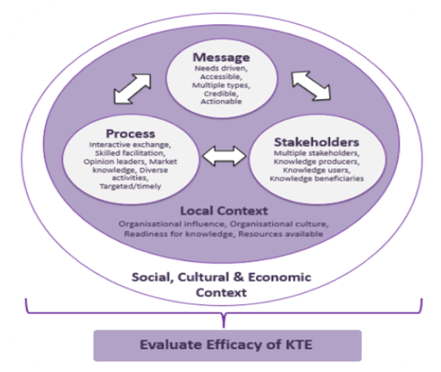
Figure 1. Knowledge transfer and exchange (KTE) model (EMTREK Model An Evidence-based Model for the Transfer and Exchange of Research Knowledge. URL: http://www.professionalpalliativehub.com/emtrek-model-evidence-based-model-transfer-and-exchange-research-knowledge)

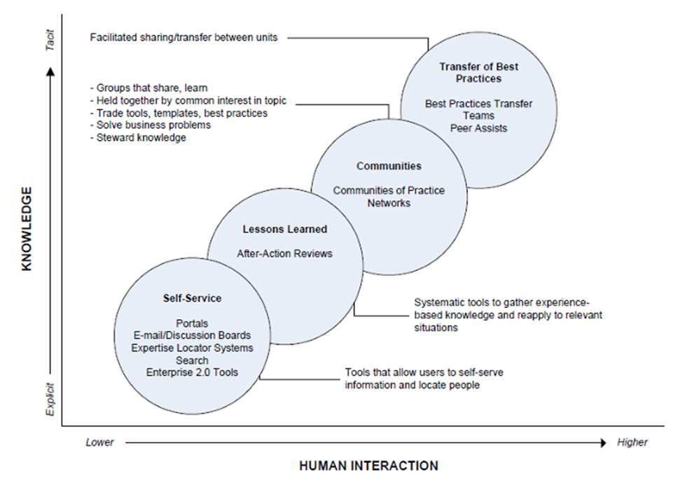
Figure 2. Knowledge transfer through best practices (Learning and knowledge sharing strategy. US Office of Personnel Management. URL: www.opm.gov%2Fabout-us%2Fopen-government%2Freference-materials%2Flearning-and-knowledge-sharing-strategy.pdf&clen=1726386&pdffilename=learning-and-knowledge-sharing-strategy.pdf)

4.2 Holistic research (economical, environmental, social)
Which misalignment is covered?
Holistic research is a crucial concept to obtain effective results in planning and strategic management. There is a strong connection between theory and practice to apply scientific knowledge to practices (Visser et al. 2019; D’Amore et al. 2022) including the riparian zones. Holistic research approach can contribute to connecting scientists and managers. Especially science-management misalignments require much more attention to holistic research to focus on problem solving related to riparian zones. Holistic approach implies three main research areas; economical, environmental and social. These need to be integrated to achieve Sustainable Development Goals (SDGs), which requires holistic research and approach (Savory and Butterfield 1999; Rakic and Rakic 2015).
What do we recommend?
Applying a Holistic research approach to riparian zones can be integrated into the engagement of stakeholders. For holistic research, first of all, a conceptual framework should be created for the diagnosis of management problems related to riparian zones. Exploratory surveys should be carried out to collect the necessary information from the managers of all stakeholders including riparian zones. With the obtained data and information, rational, practical and scientific-based policy proposals and designs can be developed for the solution of managerial problems about the riparian zones. The effectiveness of sustainable riparian zone management can be possible by operating decision-making processes with a participatory approach by working with many different management units and disciplines such as forest engineering, environmental engineering, agricultural engineering, civil engineering, landscape architecture, biology, economics, sociology, psychology, starting from the upper basins where the water begins to collect, to the lower basins, including local, regional, national and even if international dimensions (Savory and Butterfield 1999; Rahman and Rautray 2000).
Holistic research can create sustainable riparian zone management practices through effective science and management collaboration (Savory and Butterfield 1999). There must be economy, environment and social disciplines and different management levels such as governmental, regional and local authorities but also NGOs and private sector managers and decision makers. All stakeholders should come together with a participatory approach, open to cooperation and explain their demands, expectations and suggestions for riparian zone management that prioritises transparency and common interests (Behfar et al. 2008).

How to implement the solution?
There are some crucial recommendations for the implementation of a sustainable riparian zone management through holistic research:
- In order to carry out holistic research, active participation of all stakeholders should be ensured and its continuity should be monitored.
- Holistic research needs to be supported and encouraged by related disciplines.
- There is a need for the general coordinator, who will lead the design initiative to ensure effective sustainable riparian zone management.
- Stakeholder cooperation needs to be strengthened for the sustainability of holistic management.
- There are some examples (with images) of implementations below:

Examples of implementation

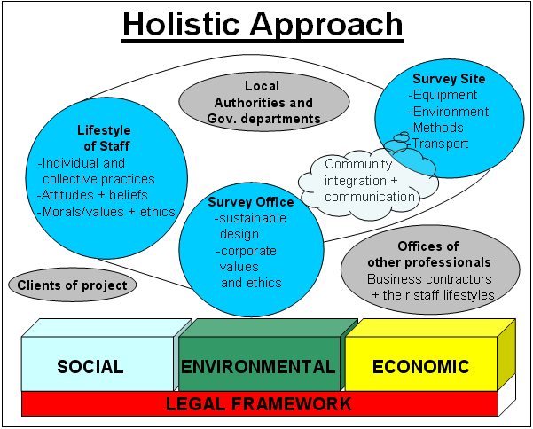
Figure3. Holistic Approach Components (Greyling,2008).

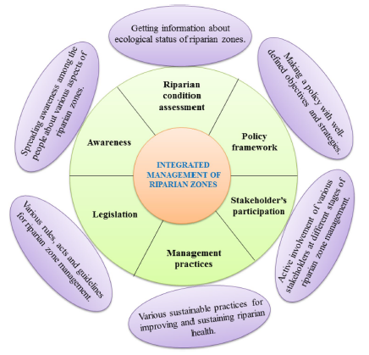
Figure 4. Integrated Management of Riparian Zones through Holistic Research (Singh et al, 2021).

4.3. Interdisciplinary research (promotion of common definition across regions and disciplines)
Which misalignment is covered?
Riparian zones are complex ecosystems including abiotic and biotic factors and processes shaping the conditions of the zone. The management of riparian zones is focused on different ecosystem services from flood risk prevention and wood production in riparian forests to the biodiversity protection and mitigation of climate change. Due to these variable expectations, the interdisciplinary research was identified as an important solution for improving science-management misalignments.
What do we recommend?
Inclusion of different scientific disciplines into basic and applied research projects focused on riparian zones. Scientists of different disciplines should be involved in preparatory activities of revitalization projects (e.g. LIFE program).
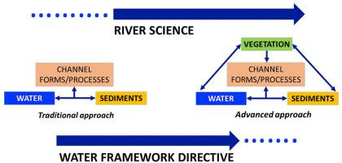
Figure 5. Traditional approach for studying river processes and advanced approach including riparian vegetation (Marta Gonzalez del Tanago, Vanesa Martínez-Fernandez, Francisca C. Aguiar, Walter Bertoldi, Simon Dufour, Diego García de Jalon, Virginia Garofano-Gomez, Dejan Mandzukovski, Patricia María Rodríguez-González 2021. Improving river hydromorphological assessment through better integration of riparian vegetation: Scientific evidence and guidelines. Journal of Environmental Management 292 (2021)

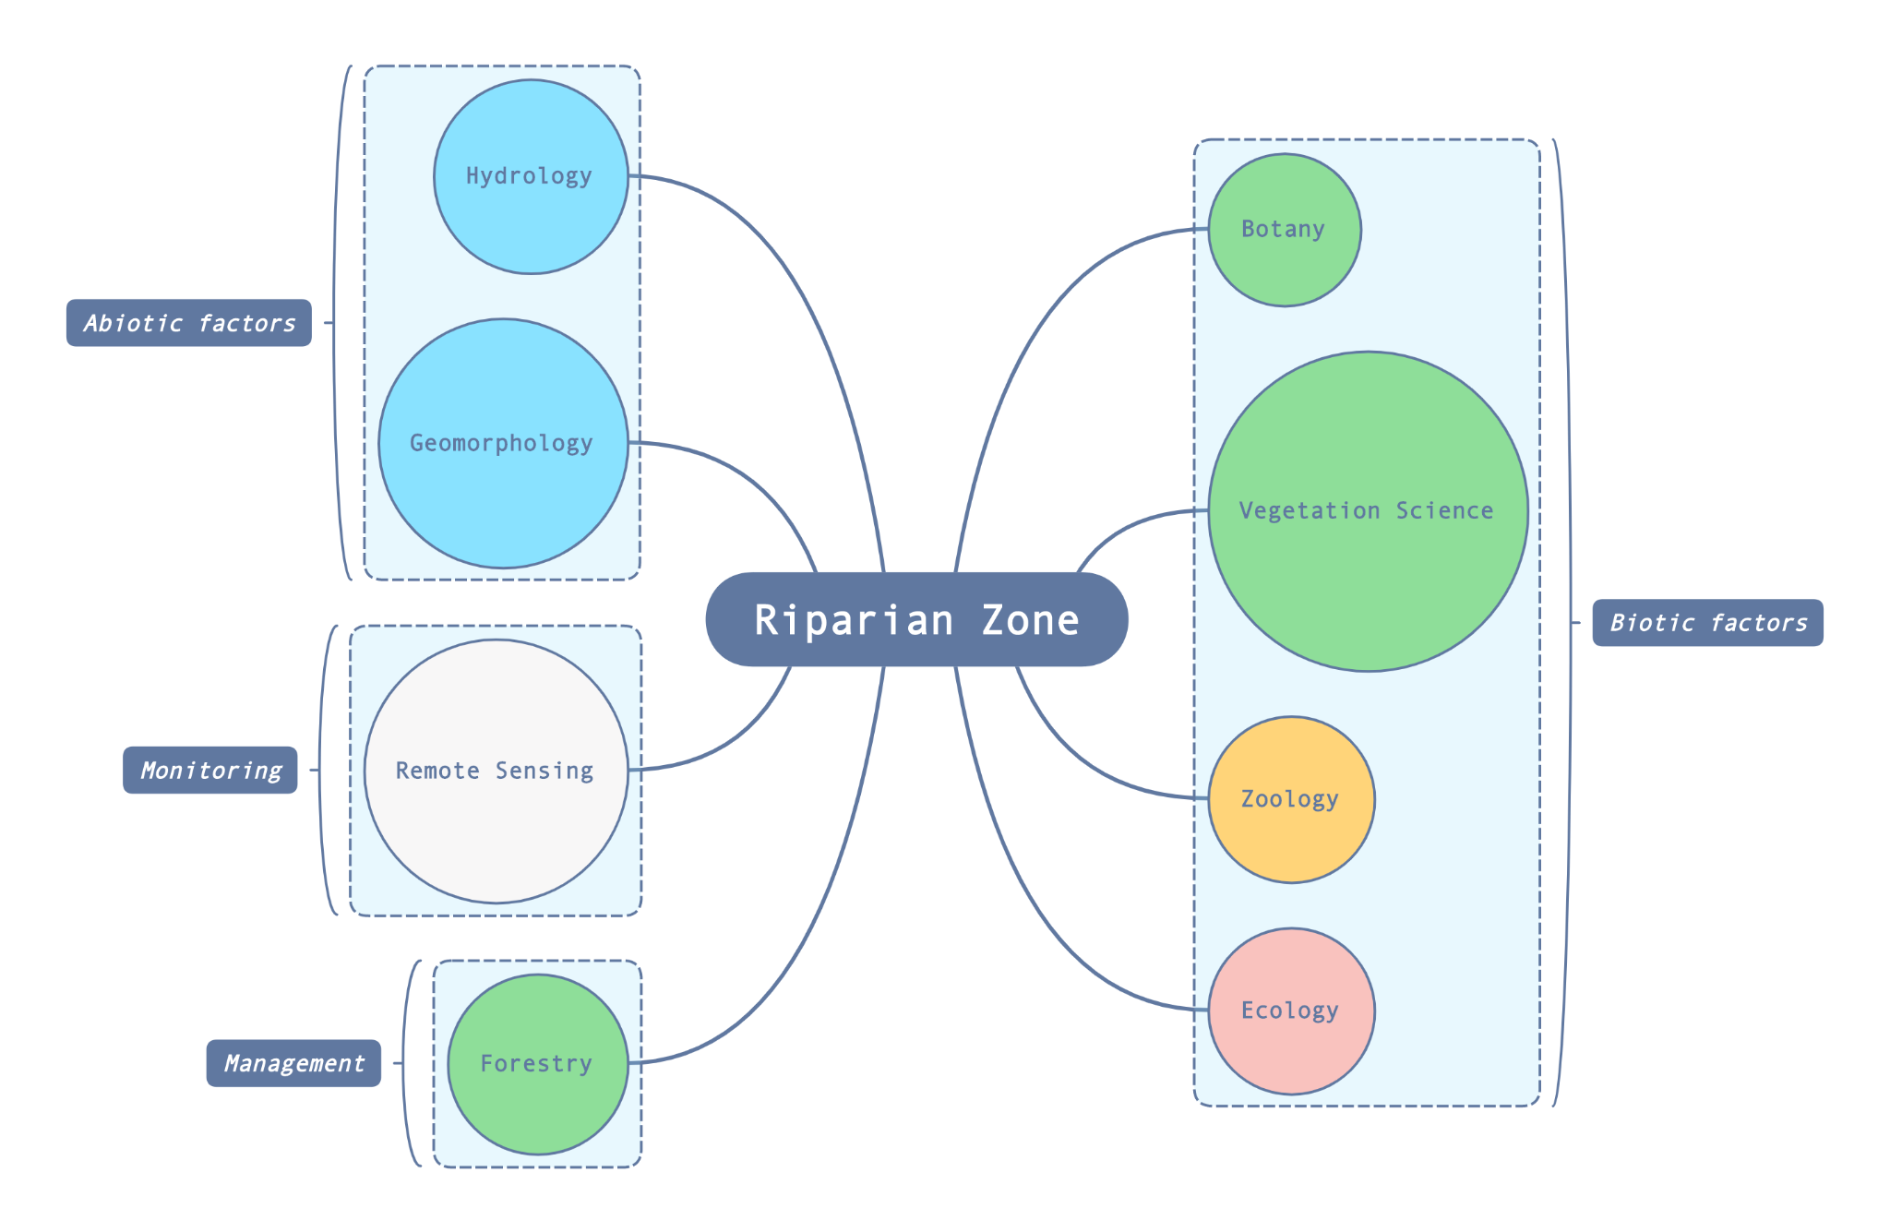
Figure 6. Scientific disciplines included in research, monitoring, and management of abiotic and biotic factors within riparian zones.
How to implement the solution?
1 - Include scientists from different fields of research in processes of documents and strategic plans preparation
2 - Establishment of interdisciplinary working groups within responsible organisations (e. g. ministry of environment, municipalities)
3 - Support of the cooperation within research and conservation projects
4 - Establishment of national and international platforms for interdisciplinary research and to ensure coordination in practice
5 - Supporting interdisciplinary research by national and international institutions and organisations
6 - Development of incentive mechanism for dissemination of interdisciplinary research
7 - Adoption of innovative approaches to strengthen interdisciplinary research

Examples of implementation
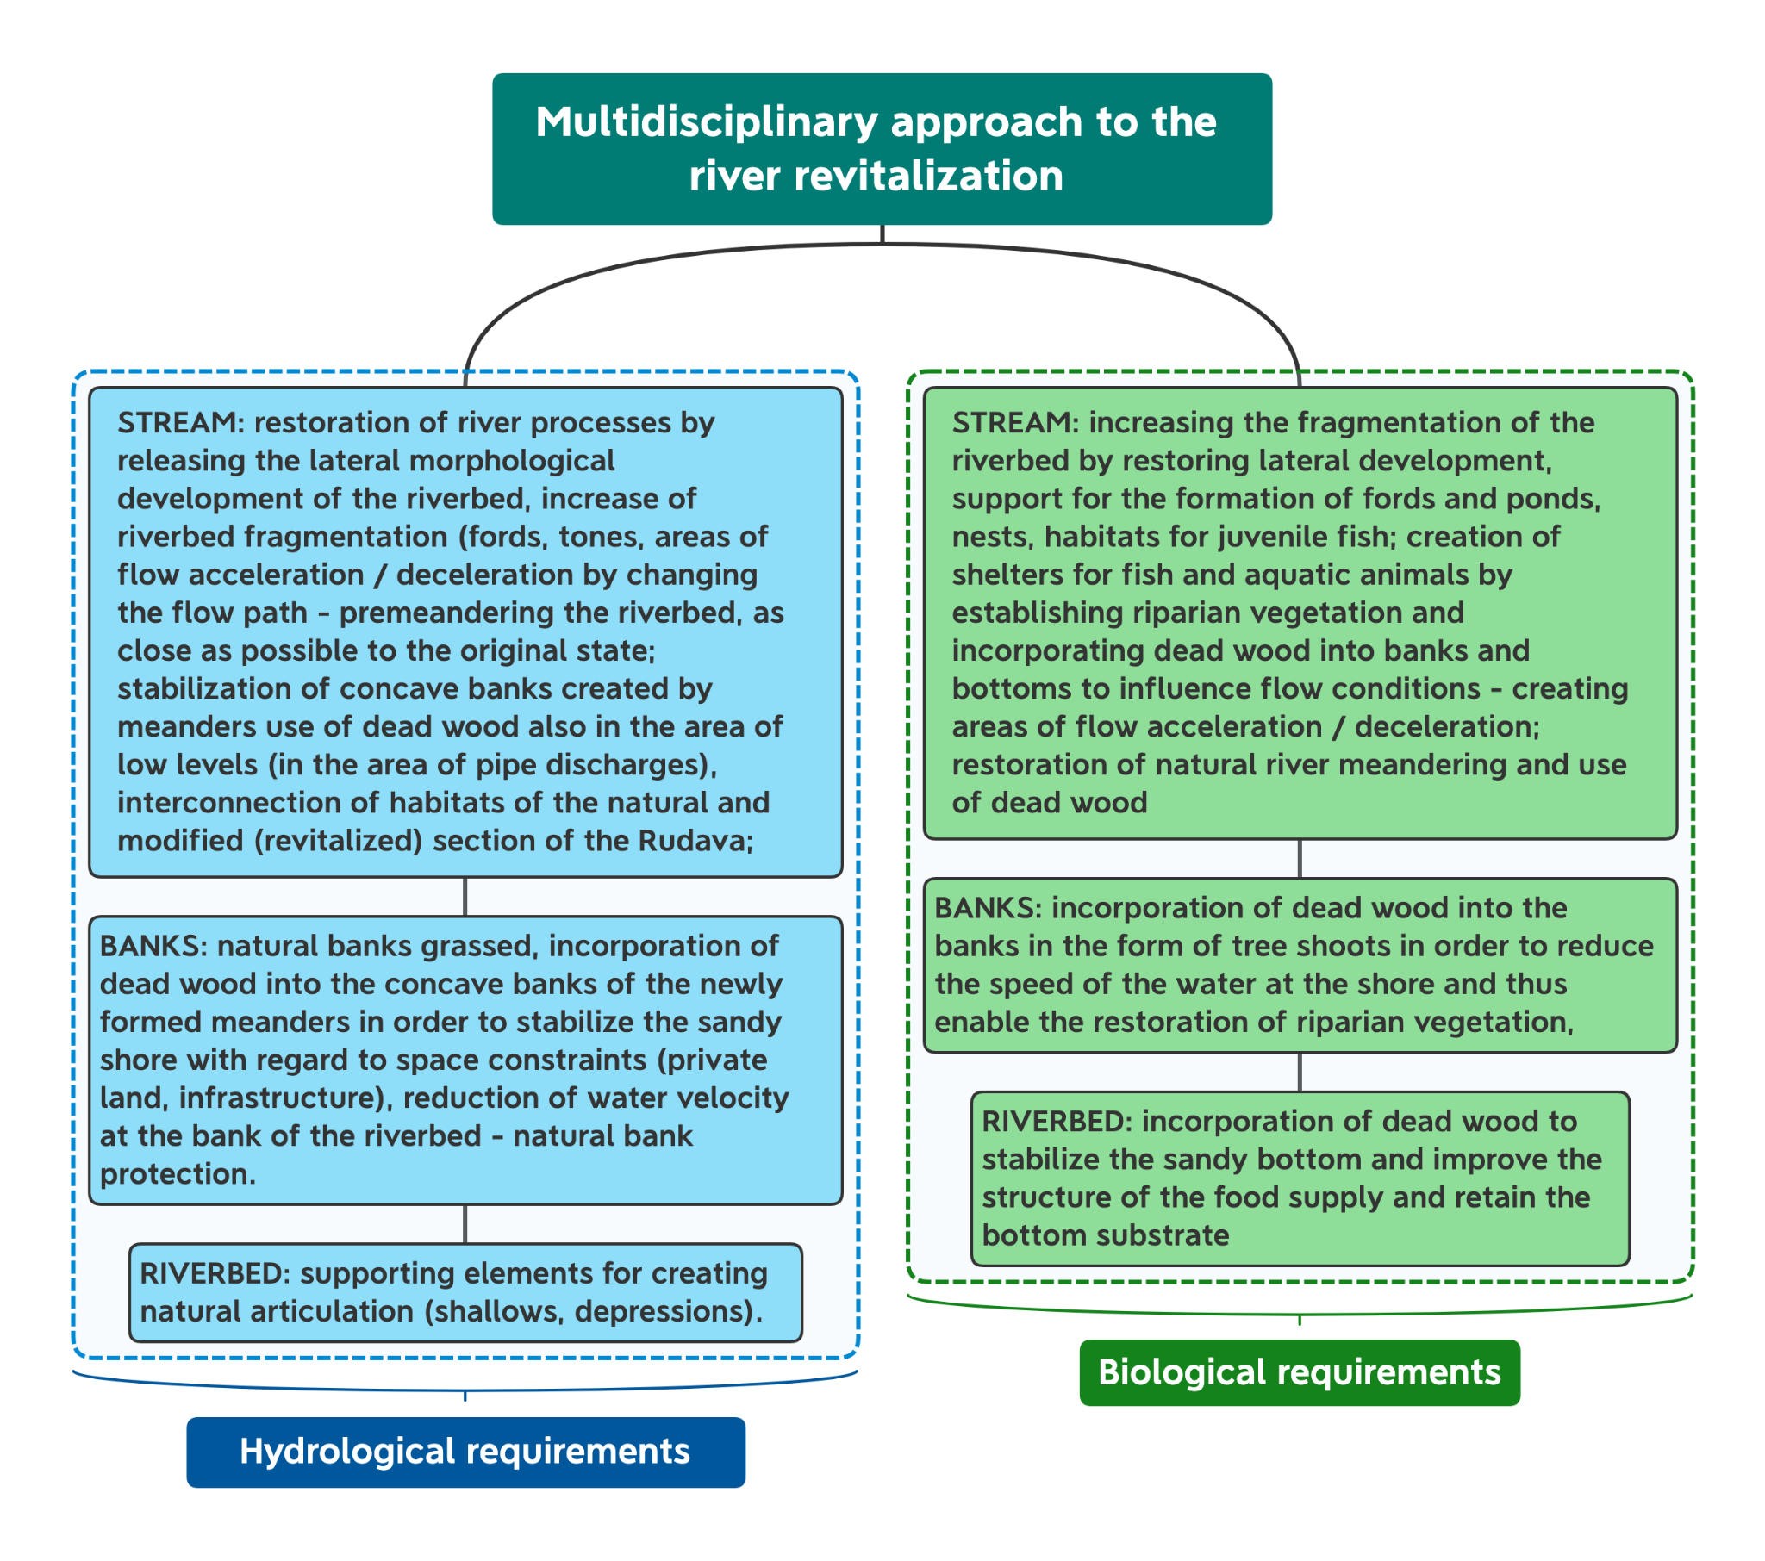
Figure 7. Multidisciplinary approach to the river revitalisation. (Škrinár A., Holubová K. 2020. Revitalization of regulated river stream of the Rudava River (Revitalizácia upraveného úseku rieky Rudava km 5,95 až km 9,96), preparatory study within the project Interreg SK/AT “Revitalization and conservation of riparian ecosystems connectivity within Alp-Carpathian corridor”)
.

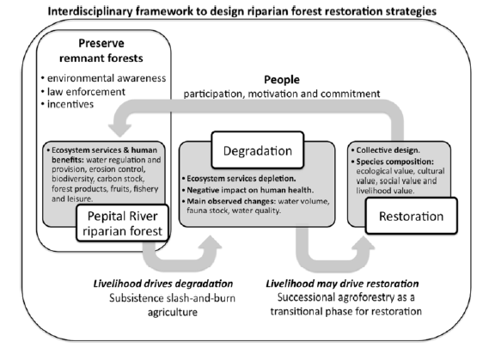
Figure 8. Interdisciplinary framework to design riparian forest restoration strategies. (Celentano, D., Rousseau, G., Lex Engel, V., Façanha, C., Oliveira, E., Moura, E. (2014). Perceptions of environmental change and use of traditional knowledge to plan riparian forest restoration with relocated communities in Alcântara, Eastern Amazon. Journal of ethnobiology and ethnomedicine. 10. 11. 10.1186/1746-4269-10-11.)

4.4 Restoration without gardening (rivers should do the work)
Which misalignment is covered?
This short guidance covers the misalignment between science and management in relation to riparian restoration. There is a riparian manager's misconception of required maintenance associated with riparian restoration (known as “gardening”) rather than sustainable and nature-based solutions. Note, this is not a comprehensive guidance.
What do we recommend?
Restoration “without gardening” focuses on the re-establishment of natural physical and ecological processes, leading to the development of natural form and features, and the sustainable evolution of instream, riparian, and floodplain habitats. At this stage, the riparian system is self-maintained and the goal of “no gardening” is achieved.
This goal is achieved by implementing different approaches, from a complete rewilding - absolutely no management - to passive ecological restoration in which the natural successional process of the plant community does the job. In this context of passive ecological restoration, land managers can direct the natural trajectory according to specific objectives, e.g. tree recruitment versus herbaceous (Chazdon et al. 2021).
In addition, restoration without gardening focuses on the cessation of anthropogenic activities that are causing degradation or preventing recovery. Under no significant physical pressures (e.g. bank protection, culverts, etc.) removing the impacting agent (i.e. human activity such as agriculture and cattle raising, and exotic plants) allows the area to recover on its own. Given the capacity of riparian ecosystems to naturally recover, often this is all that is needed to achieve successful restoration (Mikuś et al. 2019). However, in many cases, reality is much more complicated, and it is not easy or simple to completely remove all the anthropogenic stressors at once. Moreover, in most cases, natural processes require time.
How to implement the solution?
In many cases, degraded riparian areas/systems reflect a set of environmental conditions or causes that had led the system to its current state, which may differ from one region or watershed to another within the same country or between countries with similar physiographic characteristics. Therefore, we recommend adopting the following principles in order to promote restoration/rehabilitation process “without gardening” as an efficient approach for large-scale projects:
1 - Identify and map the main stressors or the ones that, if removed or significantly reduced, will have a wide positive impact on the rehabilitation of river functioning, e.g. improving flow and flood regimes.
2 - Define realistic and clear objectives for your restoration project (e.g. follow Specific, Measurable, Attainable, Relevant, Time-based [SMART] criteria). Take into account the specific environment you work: allow different principles for different environments, e.g. rural restoration vs urban restoration. People tend to assume restoration in urban environments is something close to gardening (see Figure 9). It is important to make the point that in low constrained urban environments we can also get space for sensible passive/assisted restoration that can be sustainable.
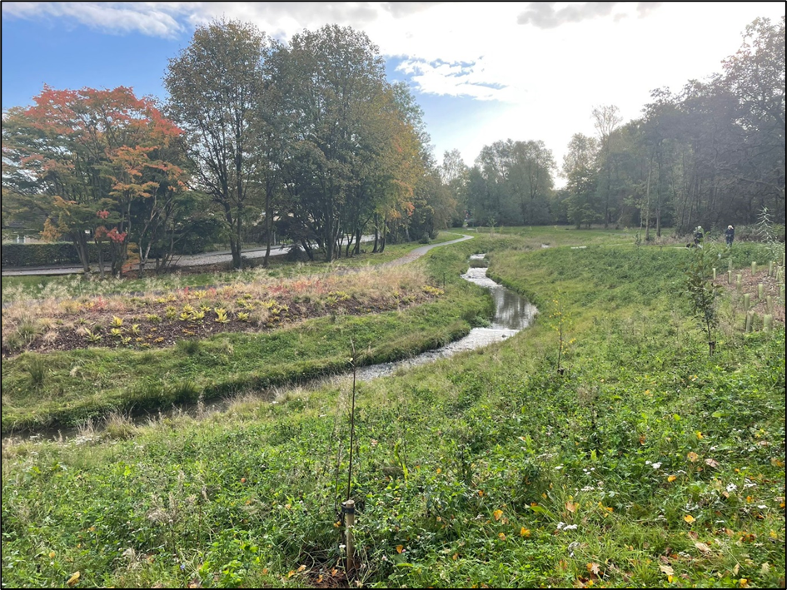
Figure 9. A section of the Tolcross river (South of Glasgow, Scotland), as an example of restoration using “gardening” principles. This channel was restored, the previous closed culvert was removed, and the river was back to flowing through an open channel. The restoration project was a significant local improvement in this local urban park, but the banks and riparian vegetation are over-managed and natural processes are not allowed to evolve (lateral erosion or riparian trees). (Photo by Fiona Caithness, SEPA)

3 - Adopt a science-based adaptive management approach, involving scientists from academia and research institutes to run applied research addressing knowledge gaps related to riparian vegetation characterization and functioning.
4 - Riparian vegetation communities surveys must start very early after stopping the disturbance, as the trajectory of the succession will influence the success of the passive ecological restoration. The knowledge on the earlier stages of the communities can help managers to decide and to modify or not the competition processes (e.g. natural tree recruitment versus herbaceous).
5 - Initiate a long term monitoring system of a limited number of abiotic and biotic variables, which will reflect the variation of benefits and ecosystems services provided by the river because of the river restoration, such as species composition, canopy cover, bare substrate, birds, river flow, temperature, etc. These data will be useful to fuel good communication among scientist-managers-practitioners. See for example, Figure 10 and 11.

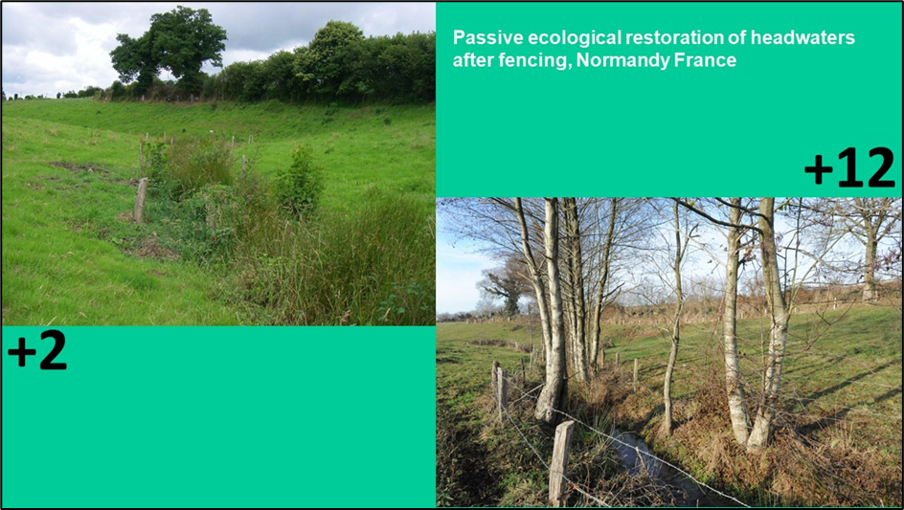
Figure 10. Passive ecological restoration of headwaters after fencing in Normandy (France) after two years (a) and 12 years (b). (Photo by Charlotte Ravot)

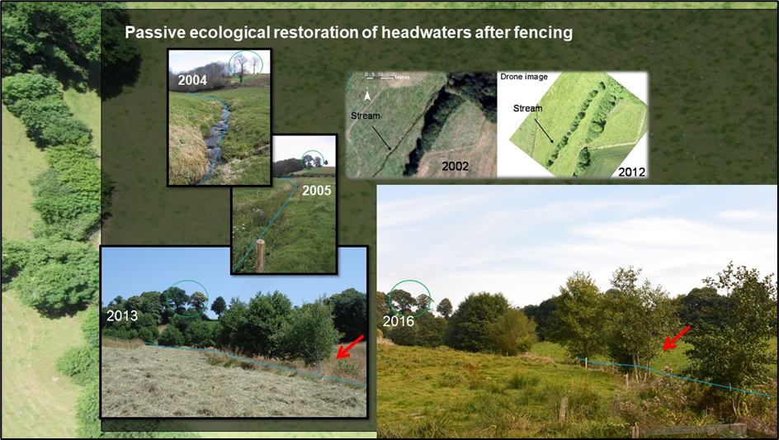
Figure 11. Passive ecological restoration of headwaters by fencing the brooks in Normandy (France) in 2004 before fencing to 2016. Red arrows show a continuous recruitment between 2013 and 2016. Aerial (2002) and drone (2012) photography (by Simon Dufour) comparison shows the importance of the new passively recruited riparian streamside vegetation (for details, see Forget et al. 2013)

6 - Generate partnerships with local communities and among stakeholders to raise awareness of the importance of the riparian zones and to the ecological services which it provides. Add a list of “To do” and “Not to do” actions ones should follow in order to participate and contribute.
7 - Develop or follow (if exist) expert guidance to help managers. The guidance has to be practical and applicable for managers. See section on Good Practice within this document.

4.5 Better knowledge of understudied systems
Which misalignment is covered?
Although frequently overlooked in limnological studies, riparian zones, as transitional areas between aquatic and terrestrial ecosystems, are an integral part of freshwater ecosystems conditioning both the structure and functioning of rivers and providing essential functions (e.g. soil fixation, organic matter supply) and services (e.g. clean water, recharge aquifers, mitigate flash flood impacts; Riis et al., 2020).
Overall, riparian communities are taxonomically very well-known, but this knowledge is not uniform across the globe. In fact, recent reviews have identified riparian vegetation studies in 68 countries (Dufour et al., 2019; Pedraza et al., 2021), which comprises just one third of the countries in the world. The largest percentage of studies was conducted in North America (over 40%), followed by Europe (22%), and South America (12% and notably the Amazon basin; Dufour et al., 2019). Therefore, there is an urgent need to develop riparian science in Asia and Africa. On the other hand, despite this unequal distribution, most biomes seem to be represented. Finally, more knowledge is required about understudied (or more recently emerging) contexts such as low-energy, urban and small tropical systems (Dufour et al., 2019)
What do we recommend?
In Europe, riparian vegetation is marginally addressed in EU normative and has been neglected in most Water Framework Directive (WFD) protocols. To overcome this misalignment, there are promising approaches for the characterization and assessment of riparian vegetation, which include the identification of vegetation units and indicators at multiple scales to support management and restoration measures (González del Tánago et al., 2021). The hydromorphological context of the WFD should be revisited and offer official guidance to integrate riparian vegetation in river hydromorphological monitoring and assessment.
Furthermore, WFD does not consider all types of rivers as official waterbodies. Despite it has been estimated than more than half of the global river network is non-perennial (Datry et al., 2014; Messager et al., 2021), WFD does not include most intermittent rivers as official waterbodies, which hinders to advance in their science and to reach a cost-effective and knowledge-based management. The dominance of non-perennial rivers is even more evident in Southern Europe, where they can suppose more than 80% of the river network (Stubbington et al., 2018), which translates into knowledge gaps (e.g., Cyprus; Manolaki et al., 2020). In a context of global change where flow intermittence is predicted to increase in vast areas, it seems essential to incorporate non-perennial rivers as official waterbodies in Europe and worldwide in order to have a complete view on river and riparian associated ecosystems. Up to date, bioassessment tools have emerged from and developed for perennial rivers so most water managers apply perennial river management principles when making decisions related to temporary streams, which could result in biassed conclusions and counter-productive conservation and restoration measures for riparian vegetation.
Regardless of the water body category under study, more emphasis on the study of the impacts of hydromorphological alterations on riparian area is needed e.g., bank degradation, density of riparian areas, alteration of natural continuity both in its lateral and longitudinal dimensions (Reyjol et al., 2014). In addition, although there has been a continuous increase in the number of publications on riparian vegetation since the 1990s, the integration of riparian knowledge across disciplines and sociocultural aspects of riparian vegetation is also needed (Dufour et al., 2019). In fact, despite the importance of cultural ecosystem services, currently it is difficult to do quantitative assessments (Riis et al., 2020). Therefore, more research on assessment, description, valuation and integration of cultural services into a decision-making seems desirable (Vidal-Abarca Gutiérrez and Suárez Alonso, 2013)
How to implement the solution?
There are several tools or approaches that can contribute to solve these knowledge gaps. In Europe, we must make a special effort to Increase the monitoring of riparian zones through the Water Framework Directive by Incorporating a more detailed riparian assessment in WFD protocols that also represent the multiple ecosystem services that they provide. It must be noted that most ecosystem services provided by aquatic and riparian communities are not well covered by WFD protocols and indices (Vidal-Abarca et al., 2016) so this should become a priority. In addition, there are other complementary approaches to official monitoring. Among them, citizen science has emerged as a cost-effective tool to increase environmental information and increase spatial and temporal coverage (scientist, managers and administrators cannot reach everywhere every time) at the same time citizens increase their environmental awareness (Bonney, 2021). The potential of citizen science is still underdeveloped in riparian systems. However, its application combined with the use of social media and internet applications will increasingly democratise riparian research and management (Rood et al., 2020). Thus, some recent studies have demonstrated the potential of citizen science to improve our knowledge on the structure and functioning of riparian vegetation (Shuker et al., 2017; Gurnell et al., 2019; Di Grazia et al., 2021). In particular, the citizen science tool “MoRPh'' include an easily measurable set of riparian and related variables (Table 1) that allows the characterization of river channel, riparian features and human pressures and impacts through 14 speficic indexes (Shuker at al., 2017; Gurnell et al., 2019).

Examples of implementation
Table 2. Broad categories of materials, physical features and vegetation properties, including human pressures and direct modifications that are characterised by a MoRPh survey. From Shuker et al., 2017
Bank top-floodplain | Bank face-channel (and established island) margins | Channel bed
Materials |  | Natural materials  Reinforcement materials | Channel bed natural materials, including degree of siltation  Channel bed reinforcement materials
Physical features | Water-related features  Artificial-managed ground cover | Natural and modified bank profiles  Natural physical features of the bank face, toe and channel margin  Artificial physical features | Natural physical features  Water surface flow patterns  Artificial physical features
Terrestrial (Riparian) and aquatic vegetation | Terrestrial vegetation structure  Tree and large wood features  Non-native invasive plant species | Terrestrial vegetation structure  Tree and large wood features  Aquatic vegetation at the channel margin  Non-native invasive plant species | Aquatic vegetation  Terrestrial vegetation, large wood and other organic matter interacting with the wetted channel  Non-native invasive plant sp

Table 3. The 14 indices currently estimated from each MoRPh survey. From Shuker et al., 2017
Index type | Index number and name
River channel characteristics | INDEX 1: Number of flow types
 | INDEX 2: Highest energy extensive flow type
 | INDEX 3: Number of bed material types
 | INDEX 4: Coarsest extensive bed material particle size
 | INDEX 5: Average bed material size
 | INDEX 6: Average bed material particle size class
 | INDEX 7: Extent of bed siltation
 | INDEX 8: Channel physical habitat complexity
 | INDEX 9: Number of aquatic vegetation morphotypes
Riparian (bank face and top) character | INDEX 10: Riparian physical habitat complexity
 | INDEX 11: Riparian vegetation complexity
Human pressures and impacts | INDEX 12: Degree of human pressure imposed by land cover on the bank tops
 | INDEX 13: Channel reinforcement
 | INDEX 14: Extent of non-native invasive plants

4.6 Education updated with new knowledge about riparian vegetation
Which misalignment is covered?
Management practices must be based on accurate and up-to-date information that has been informed by research. At the same time there is a need to generate awareness of the importance of riparian zones and their vegetation among the general public as well as policy makers so that the protection and management interventions needed are supported. Ensuring that both objectives are addressed is a challenge that requires a multi-pronged approach.
What do we recommend?
Knowledge conversion into practice needs to be underpinned by an education framework that encompasses the continuum between early and life-long learning, reaching broad and diverse audiences. For instance, targeting students in primary and post-primary schools would create awareness in the younger population of the importance of riparian zones. That awareness also should be propagated among the general public and in particular land owners, river system managers and users of rivers. For the professionals dealing with management of riparian zones or related policy there are two requirements; firstly the initial training in riparian science that is largely provided by the third-level sector, and secondly continuous refinement of that understanding through lifetime access to new knowledge as it becomes available as well as opportunities for training.
How to implement the solution?
Education Framework
The education framework requires a two pronged approach; 1. cultivating awareness and ecological understanding, and 2. professional training and life-long learning. It needs to encompass traditional education institutions but also a wide spectrum of learning opportunities for the public through other avenues, including those listed in the table below.

Target Audience | Strategy | Tools/Guidance
Primary & Second-level students | Target teacher training so that the teachers will be equipped to motivate and inform students and integrate riparian knowledge into science and geography curricula. | Posters, videos, podcasts, species identification cards, Interactive citizen science websites. Note: fieldwork training would be required
Third-level students | Enhance the riparian relevant content of modules in degree programmes and courses devoted to biology, hydrology, river management, agriculture environmental legislation etc. Facilitate riparian related projects. | Posters, videos, podcasts, species identification cards. Interactive citizen science websites. Library of case studies. Fieldwork is essential.
Land-owners | Involve land-owners in local projects and other stakeholder-centred initiatives, for instance EU LIFE and European Innovation Partnership projects. | Workshops  Field visits  Online video resources  Demonstration projects with land owners
Managers including policy and planning | Specific short immersion courses (series of one-day courses) associated with relevant professional bodies. | Library of technical and policy briefs and case studies. Links to guidance manuals and field visits.  Online CPD modules
Other practitioners (architects, engineers) | Targeted continuous professional development (CPD) modules/ These could be associated with relevant professional bodies so CPD credits awarded. | Library of technical and policy briefs and case studies. Online CPD modulse. Links to guidance manuals and field visits.
General public | Engage in citizen science.  Disseminate scientific research results through informative public media output (needs journalistic training) | Online citizen science portals advertised through all media, but especially through social media channels.  Citizen science training

Cultivating awareness and ecological knowledge
Awareness generation starts with school children and there is an opportunity to incorporate information on riparian zones and their importance into geography classes and nature studies at primary school and to science and geography curricula at second level. Indeed, riparian zones could be highlighted as a key location for nature studies. Enabling teachers with the knowledge, skills and motivation to explore and engage students in exploration of riparian zones is central to awareness generation at both primary and second-level education. While some training can be provided online it must be supplemented with field experience.
Public and land-owner engagement should be community based and ideally integrated into community projects such as EU LIFE, LEADER and European Innovation Partnerships. The training should encompass information on the importance of riparian zones and their vegetation in terms of ecosystem services delivery and biodiversity protection as well as the impacts of degradation on the various benefits. Exposure to this type of information can lead to a level of knowledge and more positive attitudes that can promote actions to improve riparian health. However, implementation of measures by land owners will be dependent on financial incentives, which are generally part of the aforementioned community-based projects.
Some examples of the education material used are provided in section on examples of training and engagement activities.
Professional Training
Training is not just required by those who are directly responsible for management of riparian zones and their vegetation but also by those involved in the policy arena including land-use planning, environmental policy, as well as development projects (e.g. planners, architects and engineers). This will require a review of the content of ecological, agriculture, forestry, engineering, bioengineering and architect degree programmes and other courses for appropriate riparian related content that can inform both policy and practice among professionals. The responses to the Questionnaire completed by the COST Action participants (51 responses from 17 countries) that focused on third-level training highlighted variable content, which was not always directly focussed on riparian zones and vegetation, as well as knowledge/training gaps. For example, the top three key riparian related subjects taught are instream ecology, water management and forestry. Other areas highlighted were hyporheic zone, engineering, hydraulics, geomorphology and legislation. Although riparian systems are taught to undergraduates and post graduates, they are most often addressed in modules part of Master’s programmes. However, with some exceptions most of these modules are not fully focused on riparian systems. While the approaches are at least in part interdisciplinary and transdisciplinary, legislation, management approaches and field experience are not consistently covered. Importantly, riparian education needs to better integrate the legal framework.
Examples of implementation
In this case maybe we can consider the examples are those provided in the section “how to implement”
The following are some examples of community-cased projects that have a significant focus on riparian zones, their health and benefit for water quality protection.
- ‘Cows and Fish’ programme (see https://cowsandfish.org/#)
The Alberta Riparian Habitat Management Society, also known as ‘Cows and Fish’, began its goal in 1992 to work with communities on riparian awareness, in order to improve the way that riparian zones are managed, and to enhance environmental quality and overall ecological function of riparian zones (Maclaclan et al. 2006)). The programme is based on five elements: Awareness & Education (addressed through workshops, field days, hands-on learning); Team Building (knowledge sharing), Tool Building (e.g. fact sheets, demonstration projects, technical liaison to assist landowner find practical solutions), Community-based Action (community participants and landowners drive action) and Monitoring (establishing baseline information on riparian health and follow-up repeated monitoring to assess progress).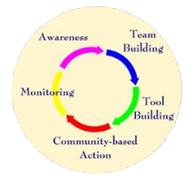

improve their capacity to protect surface waters from diffuse pollution.Figure XX Five elements of the Cows and Fish programme. From: https://cowsandfish.org/about-us/
.
As noted by MacLachlan et al. (2006) life-long learning in this and other projects can be facilitated by having access to a) educators as guides to sources of information, b)learning -by-doing, c) group learning and d) access to assessments of riparian health and responses to interventions.

- Fact sheet produced by Teagasc , Ireland
https://www.teagasc.ie/media/website/publications/2021/Riparian-Buffer-Zones.pdf
Teassc, the Agricultural and Food Development Authority in Ireland produced a fact sheet on riparian zones as part of a package of information on how to protect and improve water quality. The fact sheet covers establishment of riparian buffer zones and tips to improve their capacity to intercept diffuse pollution.

- Duhallow Farming for Blue Dot Catchments EIP https://www.irdduhallow.com/environment/duhallow-eip/
This European Innovation Partnership project, launched in 2019, is engaging with the farming community in the river Allow-Dalua catchment to protect and restore the high ecological status of the catchment through an innovative results based payments scheme. Measures are being based on the source-pathway-receptor model which involves reducing pollutants at source, intercepting them before reaching the river and restoring impacted habitats.Riparian measures feature strongly from stabilisation of eroding banks using for example willow (Salix spp.) to riparian woodland establishment. Farmers participating engage in training and workshops which range demonstration farm walks, citizen science and river biology.
- Portuguese Project “Voluntariado Ambiental para a Águ
This is a citizen science Project from the Portuguese Environment Agency that since 2009 promotes the monitoring of rivers and streams according to the Water Framework Directive in the South of Portugal. The participants have specific training and the information produced is audited by universities, being used by the regional water authorities as a complement of official monitoring. The volunteers also participate in the development of actions to enhance and restore ecosystems stretches of rivers and streams, such as planting of native species and removal of invasive species. https://voluntariadoambientalagua.apambiente.pt/Site/FrontOffice/default.aspx.
- “Projeto Rios” is an Iberian project that in Portugal is coordinated by the Portuguese Environmental Education Association (ASPEA). This project encourages the adoption of 500m stretches of rivers or streams usually organised by local schools. Using a simple but rigorous observation methodology, easy to apply and develop, the groups assume responsibility for monitoring and protecting the chosen river or stream or river reach. The project emerged with the aim of contributing to the implementation of plans for the rehabilitation of rivers and streams, with the involvement and accountability of the community, with a view to sustainable development, education for citizenship and local and regional growth (https://aspea.org/index.php/pt/projeto-rios).

4.7. Advertising good practices - community awareness
Which misalignment is covered?
This short guidance covers the misalignment between science and management in relation to application of good practices and community awareness in dealing with riparian vegetation. Riparian practices and projects are many times implemented without scientific basis and/or in a non-consistent way within the existing riparian conditions and constraints. A recommendation/solution is provided to help with a better mutual understanding of the different needs to improve future actions. Note, this is not a comprehensive guidance.
What do we recommend?
The main recommendation for a better advertising of good practices, including community awareness, is to improve communication between scientists, managers (e.g., basin authorities, river trusts, regional and local authorities, private sector, environmental agencies, and other public institutions), practitioners and communities, including landowners and farmers. This communication needs to find ways to produce realistic and easy-to-apply guidance. The structure and content of the guidance should be agreed by the different stakeholders; thus, the guidance should be supported by the most-up-to-date science, in line with the existing regulatory and policy principles but applicable on site and preferably including examples of good practices. The tools and methods presented in the guidance should be clear and easy to understand for all parties involved in the process of managing riparian vegetation. Also, practitioners should be able to apply the methods and tools on different and diverse environments (i.e., not site specific). Ideally, the guidance should be regularly updated involving all stakeholders. Some literature (Singh et al. 2021) developing on this has shown the interlinks of the different parts, see figure 1.

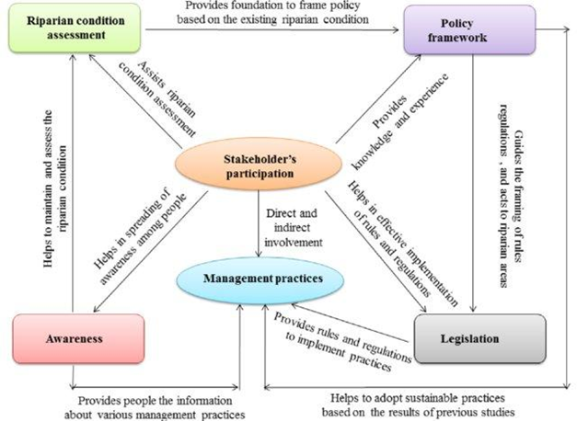
Figure 12. Managing riparian zones for river health improvement (Singh et al. 2021)

How to implement the solution?
Every country and region will need to follow different processes to achieve the solution, the points described below are general principles to help implement a useful route for a better advertising of good practice on riparian vegetation and riparian zone management.
- Academics and managers (including communities’ representatives and practitioners when possible) should identify a communication channel to create more fluid links between communities. River basin authorities could contribute to this process providing access to all parts in different consultation processes. Academics should be a regular party within these forums. Regular face-to-face or virtual meetings to discuss good practice and common/recurrent riparian issues in local communities should provide a good start to create/update good practice. The information, material produced in the meetings and updates should be available to everyone (on-line) and disseminated widely via different means (email, web, local radio, tv, social media, etc.), coordinated by the governmental entities responsible for water management and nature conservation.
Additionally, the use of new promising technologies including satellite imagery, LiDAR and unmanned aircraft systems, would greatly assist riparian research and management communication. Remote sensing tools are reducing the need for some expensive field measurements, with satellite imagery expanding in coverage and duration, and increasing in resolution (Rood et. al. 2020).

- Different working groups should agree on the preparation of different materials to help manage riparian vegetation. The different groups should include experts in different aspects of the riparian environment:
  - Academics would provide the most-up-to-date science and tools. The scientists will need to “translate” the science into something understandable, useful and applicable and influence policy.
  - Different managers would present the different regulations in place and future aspects of policy that could affect riparian elements. Managers will need to adjust and modify regulation to accommodate new developments in science and tools to improve the environmental and social benefits and create resilience systems for climate change.
  - Practitioners and communities should input to allow the creation of a practical guidance that can be applied on the ground.
- The working groups should produce guidance that all different parties agree with. This guidance must be:
  - Clear and easy-to-understand, science based but clearly explained to be understood for a variety of public.
  - Realistic, it must resolve real problems and be prepared to be implemented on site.
  - Functional and being able to deal with different riparian environments (e.g., river scale, different pressures, etc.). Therefore, applicable to diverse morphologies.
  - In some cases, it could be useful to create different levels of guidance for different users and different ecosystems and land-settings.
- To promote good practice. The working groups should keep working together once the good practice guidance has been created. These groups should be promoting good practice together and take part in joint initiatives, e.g., supporting case-studies, days out to work together on different sites:
  - The working groups should promote different events in local authorities, local groups, NGO’s, webinars, etc. to present the outcomes of the good practice guidance and explain how to use it.
  - These groups should create opportunities to meet new scientists, managers and communities to create open debates.
Monitoring and updating. As part of the regular discussions of the working groups, monitoring of the state of the good practice guidance should be made effective by reviewing cases where the guidance has been implemented and amending the guidance accordingly, either based on previous applications, changes on regulation or new scientific advances. It is important that all these changes are logged and communicated to all parties in an appropriate manner through sensible channels.

Examples of implementation
There are some examples of Good Practice Guidance developed in Scotland (figure 2) and being reviewed at the moment involving scientists, managers and regulators in Scotland. Link to the guidance: Riparian Vegetation Management - Good Practice Guide

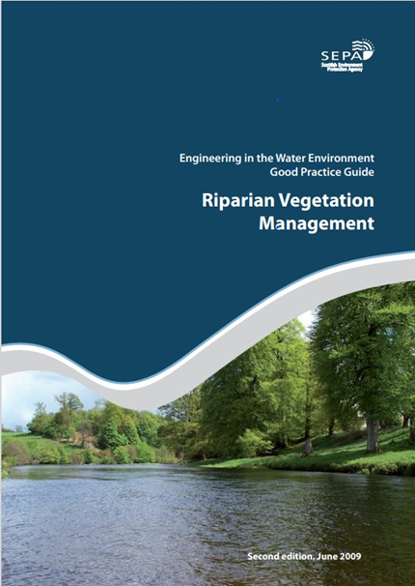
Figure 13. Riparian Vegetation Management Guidance, a guidance of good practices developed by the Scottish Environment Protection Agency 2009, SEPA. (https://www.sepa.org.uk/media/151010/wat_sg_44.pdf)

4.8 Integration of conservation of genetic diversity in riparian ecosystems
Which misalignment is covered?
The genetic diversity and integrity of many riparian tree species is reduced by habitat degradation, fragmentation (Smulders et al. 2008), and hybridization with non-native species (Vanden Broeck et al. 2004), potentially leading to low resistance to pathogens and extinction. However the genetic perspective has seldom been considered in conservation and ecological restoration schemes, despite that it can be critical for their success (Cortina-Segarra et al. 2021).
What do we recommend?
To remedy this situation, we recommend that strategic plans for conservation of genetic diversity in important riparian plant species are made, and to increase the efforts to monitor and assess the genetic status of multiple riparian species. In practical conservation and ecological restoration efforts, it is vital to protect a network of natural areas serving as seed sources, and to reinstate natural processes, to enable dispersal and regeneration of native species. When seeding and planting are needed, native local provenances should be used, the availability of which can be enhanced by documenting and collecting from in situ and ex situ seed sources.
How to implement the solution?
The formulation and implementation of strategic plans for genetic resource conservation can use the Global Plan of Action for the Conservation, Sustainable Use and Development of Forest Genetic Resources (2014), and its implementation strategy (http://www.fao.org/3/i3849e/i3849e.pdf), an outcome of the EUFORGEN programme, that encourages countries systematically to collect genetic data and to establish a core network of dynamic genetic conservation units across Europe (www.eufgis.org). Improving policies on genetic considerations are especially important as most species are non-commercial and regulations are required to control/certify the origin of the plant material that is made available in nurseries.
Inclusion of genetic diversity in monitoring and assessments of the population status of native riparian tree species and recognition of trajectories in long-term monitoring are needed to ensure ecological integrity of riparian genetic resources in the future. Alimpic et al. (2022) suggest a framework for conducting such assessments. Crucial aspects of conservation of genetic resources are the protection of a network of natural riparian areas serving as seed sources, along with reinstating of conditions that facilitate natural dispersal and regeneration of native species (such as natural flow regimes) (Vanden Broeck et al. 2021) and reduces introgression of exotic cultivars (Chenault et al. 2011).
In riparian restoration schemes involving seeding or planting it is vital that genetic diversity is ensured, and that locally adapted, native provenances are used. To ensure this, guidance on best practice in the management of plant reproductive material from local native populations (such as propagation of cuttings in the field having high genetic diversity; seedlings with identified and certified origin) is crucial. Also, to increase resistance to emerging pathogens, selection of multiple individuals with confirmed resistance to target alien/invasive pathogens, in species such as elms, ash and alder (Bjelke et al. 2016), is important. To enhance availability of local provenances for seeding and planting, networks of seed orchards, clone collections, seed collections, arboreta, botanical gardens and gene banks, which adequately represent the genetic diversity of natural populations (Storme et al. 2004) must be available.

Examples of implementation
As a case study, the conservation work on the black poplar (Populus nigra), one of the most threatened tree species in Europe (Smulders et al. 2008), may serve as an example for how to manage genetic diversity of other riparian tree species. A 60 km section of the River Meuse on the border between Belgium and the Netherlands has been restored, re-instating the natural dynamics of floodplains (Van Looy & Kurstjens 2022), along with planting of P. nigra. These efforts have increased the population abundance of P. nigra (Figure 14) and reduced hybridization with exotic cultivars to low levels (Vanden Broeck et al. 2021). These in situ conservation actions are supported by ex situ measures to preserve indigenous genetic material (Storme et al. 2004). For example, in Italy, long-term ex-situ collections of Consiglio per la Ricerca in Agricoltura e l’Economia Agraria, www.crea.gov.it) have already supported river restoration.
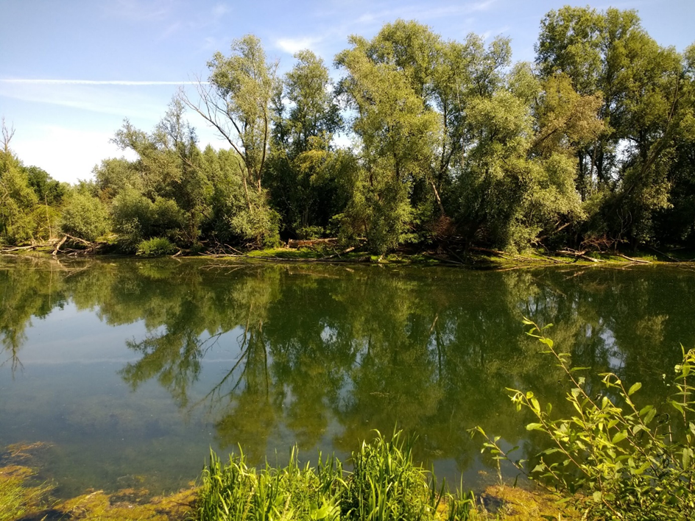
Figure 14. Restored riparian zone with black poplars Populus nigra along the Meuse River. Photo. Kris van Looy, from Van Looy and Kurstjens (2022).

4.9 Open source tools about RV (management, citizen science)
Which misalignment is covered?
As mentioned before, two of the current management challenges are the necessity of guaranteeing qualitative and long-term inventories and monitoring; and the importance to invest in environmental education for both local people and technical staff (Gonzalez et al., 2017).
Presently, riparian vegetation is still poorly incorporated in many of the procedures intended to monitor rivers across Europe. The qualitative and long-term inventories and the monitoring based on field work and on aerial photo interpretation are time consuming and expensive. As a consequence, a cost efficient up-to-date monitoring is required.
What do we recommend?
Open source tools
Remote sensing techniques, which have undergone a marked development in recent years, are a useful tool to get accurate long term information about riparian vegetation in an easy and effective way.
The Copernicus Open Access Hub (previously known as Sentinels Scientific Data Hub) provides complete, free and open access to Sentinel-1, Sentinel-2, Sentinel-3 and Sentinel-5P user products, starting from the In-Orbit Commissioning Review (IOCR). Sentinel Data is also available via the Copernicus Data and Information Access Services (DIAS) through several platforms. The time resolution is 5 days.
The Copernicus Global Land Service (CGLS), a component of the Land Monitoring Core Service (LMCS) of Copernicus, provides geographical information on land cover and its changes. Several products related to vegetation are available (https://land.copernicus.eu/).
- Fraction of Vegetation Cover (FCover) - fraction of ground covered by green vegetation,
- Leaf Area Index (LAI) – half the total area of green elements of the canopy per unit horizontal ground area.
- Land cover maps - spatial information on different types (classes) of physical coverage of the Earth's surface.
- Normalized Difference Vegetation Index (NDVI) - indicator of the greenness of the biomes.
- Vegetation Condition Index (VCI) compares the current NDVI to the range of values observed in the same period in previous years.
- Vegetation Productivity Index (VPI) assesses the overall vegetation condition by referencing the current value of the NDVI with the long-term statistics for the same period
The Copernicus Land Monitoring Service's (CLMS) product Riparian Zones (RZ) aims to provide detailed Land Cover / Land Use (LC/LU) mapping results, with a Minimum Mapping Unit (MMU) of 0.5 ha. This product provides a consistent and very-high resolution delineation and characterisation of the Riparian Zones of major and medium-sized rivers (Strahler levels 2-8) for 38 EEA member and cooperating countries + UK. Three complementary product groups provide detailed information on the state and characteristics of riparian zones for supporting biodiversity monitoring and mapping and assessment of ecosystems and their services. The Riparian Zones products will support the objectives of several European legal acts and policy initiatives, such as the EU Biodiversity Strategy to 2030, the Habitats and Birds Directives and the Water Framework Directive.

Citizen science
Also citizen science, given their potential to collect large amounts of data and their cost-effectiveness can also be considered a good source of long term monitoring data on riparian vegetation.
Citizen science can be understood as the active engagement of volunteers without scientific training in the scientific process.
Some basic requirements are needed such as the data must be scientifically proven; datasets needed to be complete and comprehensible; and the information produced should be linked to national management/scientific platforms in order to be used.
Citizen science projects have been increasingly encouraged by European Union policies in recent years (https://eu-citizen.science/).
There are many citizen science platforms being developed and made accessible for a range of stakeholders, including citizens, scientific institutions, public administrations, policymakers, and the media, with an overall aim to mainstream citizen science projects and activities at city, regional, national, and international levels. Citizen science platforms can be useful for nonscientists to take part in scientific research across a range of disciplines. There are some citizen science platforms can evaluate to integrate the riparian zone management such as CitizenGrid, Zooniverse, hackAIR, CAPTOR, Luftdaten.info, CitSci.org, SPOTTERON, CitizenLab, Foldit, Artportalen, ScienzaCollaboratva, JRCcitizenscience platform and EU.Citizen-science (Liu et al. 2021).
Promoting citizen science will also contribute to increasing managers and society awareness on riparian vegetation.

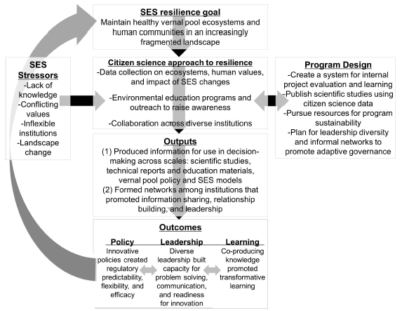

Figure 15: The citizen science collaboration, information sharing and relationship building through SES (SES: social-ecological systems) for riparian vegetation and management (McGreavy et al., 2016)

How to implement the solution?
Open source tools
The open source tools have a large advantage in relation to other tools because of their low cost of implementation when compared to other tools not open source.
The use of open source tools is a good example of the importance of a good communication channel between public authorities, at different levels, governmental, regional and local, mainly water and nature conservation managers, and researchers, in both directions.
For managers it is important to inform the scientific community about their needs and also to be aware of the tools that can be developed or improved. And to researchers it is relevant to know which tools are necessary to develop or improve in order to be applied in riparian vegetation management and enhancement.
The development of joint projects facilitates the interaction between all the interested parties and it is an easy way for scientists to pass information to managers. The implementation of case studies is also important in order to allow a better understanding of the advantages of new tools, for example.

Citizen science
Concerning Citizen Science see 4.5 Better knowledge of understudied systems.

Examples of implementation
Open source tools
The Dutch National Water Authority ‘Rijkswaterstaat’ (RWS) developed an operational web-based monitoring tool that analyses sentinel-2 data on the fly though Google Earth Engine to provide an overview of the current state of the vegetation in the entire floodplain area of the Dutch river systems Rhine and Meuse. The tool compares a map of allowable vegetation with the remotely sensed current situation for a quick scan of hotspots and can create reports on the cadastral (landowner) level. It is the first open access tool to present daily and automatically updating (Sentinel-2) satellite image analysis for floodplain management to a large group of end-users. The operational version of the vegetation monitoring tool can be found on https://vegetatiemonitor.netlify.com/#/verken (in Dutch) (Geerling et al, 2021).
Citizen science
The RiVe methodology was firstly developed in 2020 (Gumiero et al. submitted), it provides a webpage addressed to citizens, available both in Italian and English language, deals with riparian vegetation, its importance to river systems and to human societies, as well as the anthropic pressures it is subject to.
The citizens are driven into a deeper comprehension of river environments and part of the rationale behind the questions they are going to answer in the field. In order to enhance volunteers’ comprehension, the concepts introduced are explained in a simple way and accompanied by explanatory pictures. Within the webpage the user can visualize the instructions to download a specific smartphone application (RiVe App) and to properly use it to monitor riparian vegetation.
A special focus is given to a set of 12 woody species of which abundance is detected through 5 coverage classes (absent, rare, abundant common, dominant). This target species, belonging to functional groups of ecological importance, namely native (hygrophilic, mesophilic) and invasive, of which several representative photos and brief descriptions are provided.
The analysis of both higher canopies and forest regeneration layer furnishes significant information, not only on current riparian wood composition but also on ongoing shifts in vegetation composition.
At the same time, an index of riparian naturalness was designed to be integrated with the methodology. This index provides a synthetic evaluation of riparian vegetation naturalness based on the data collected by citizen scientists and can be an interesting tool to highlight critical situations or, on the other hand, to assess the positive results of virtuous management choices (involving the community in the process).
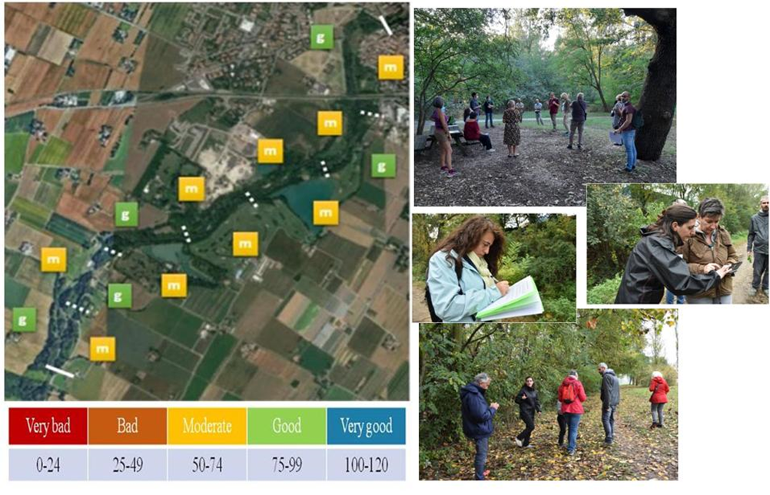Figure 16. An example of the index final score calculated at the reach scale. Depending on the score obtained, five quality classes are identified, going from very bad to very good status. The application of the index in the study area highlighted moderate to good values. On the right are some pictures of training and monitoring activities by citizens (Gumiero, in press).

4.10 Conceptual models stating pressure-impact-RV status
Which misalignment is covered?
Conceptual models relating processes and variables are very useful tools for evidencing the available knowledge on pressures, impacts and status relationships. They graphically represent potential causality, reflecting our degree of understanding of the involved mechanisms, and should be used to support potential management options (Elliot, 2002; Smith et al., 2016; Falchetta et al., 2019). Simplified conceptual models will act as valuable graphical tools easily understood by the stakeholders. They facilitate appropriate communication across managers and the public.

What do we recommend?
How to implement the solution?

Examples of implementation

These three points are presented jointly with another structure, and the figures are missing so this needs to be completed before doing the review.
Usefulness of conceptual models
Conceptual models relating processes and variables are very useful tools for evidencing the available knowledge on pressures, impacts and status relationships. They graphically represent potential causality, reflecting our degree of understanding of the involved mechanisms, and should be used to support potential management options (Elliot, 2002; Smith et al., 2016; Falchetta et al., 2019). Simplified conceptual models will act as valuable graphical tools easily understood by the stakeholders. They facilitate appropriate communication across managers and the public. Furthermore, conceptual models may also help to identify gaps in knowledge and guide forward research (Figure 1).
In the case of riparian corridors, the need of simplified conceptual models stating the influence of pressures on the water-related physical processes influencing riparian vegetation status is paramount. Establishment, growth and succession of riparian vegetation are closely dependent on water availability and fluvial landform dynamics (Gurnell et al., 2016). These are very frequently modified by human activities such as flow regulation, agriculture and urbanisation or channelization and dredging. A precise understanding of the effects of these pressures on vegetation life-stages and characteristics results crucial for addressing proper management options.
Figure 1.- Schematic evidence-based approach to define conceptual models of causality, representing useful tools to argument and communicate management options and guide policy actions and further research.

Process-based diagrams stating pressure-impact-RV status. -
Multiple pressures act simultaneously in most rivers, and their effects are cumulative across temporal and spatial scales. Scientists and managers must face this complexity (Polvi et al., 2020), that in the case of riparian corridors is established from the broadest geographical scale framed by the climate change context to the smallest vegetation patch or plant site scale influenced by local hydromorphological settings (González del Tánago et al., 2021).
Figure 2 considers main hydro-morphological processes within the basin determining the overarching framework of fluvial typology and dynamics of channels and riparian corridors. Pressures altering hillslope processes such as agriculture or urbanisation that interact with infiltration processes, likely alter possible paths of water moving downhill and the amount and timing of runoff reaching the river network. Agricultural practices, road construction or timber harvesting frequently represent human activities that increase soil erosion and sediment delivery to channels. These and other potential pressures at watershed scale will ultimately modify the hydrogeomorphic context where riparian corridors are established and develop.
Figure 2.- Main hillslope processes interacting at basin scale that determine runoff, soil moisture and sediment supply to fluvial systems. They frame the dynamism and morphological context of riparian corridors. In brackets, human activities, or potential influence on the reported processes.

Figure 3 shows schematic interactions of human pressures with fluvial systems at landscape scale, affecting portions of the basin where human influence may be more remarkable. Irrigation is nowadays very common in Mediterranean countries, but climate change may enlarge its regional occurrence to sustain productivity of high-water demanding crops. Flow regulation by dams and reservoirs results unavoidable in these cases, implying strong environmental effects. By decreasing magnitude and frequency of flooding, river damming reduces riparian zones, increases vegetation cover and changes species composition (Aguiar et al., 2018). Urbanization is one of the most frequent drivers of flooding control and river channelization, usually implying the artificialization of riverbanks and proximal areas of riparian zones. It also promotes the reclamation of floodplain areas for human activities not compatible with flooding, fostering the pavement of soils, the destruction of natural landforms and very frequently the total remotion of riparian vegetation. With different influence according to the geographical context, these pressures are strongly related to the impacts and status or riparian corridors, in many cases with synergistic and cumulative effects across the basin reinforced by the associated impairment of eutrophication and pollution of water.
Figure 3.- Main pressures affecting riparian corridors by altering hydro-morphological conditions and available soil moisture and nutrients for vegetation establishment and growth.

Finally, figure 4 conceptualizes the potential effects of pressures on riparian vegetation characteristics at reach or vegetation patch scale. These characteristics will differ from natural or referenced conditions according to the intensity of human manipulation altering hydro-morphological and biological processes. From this multi-scale exploration of potential causal agents, decision-makers and river managers may design guidelines and strategies to mitigate pressure effects, reduce impacts and enhance riparian vegetation status.

Figure 4.- Conceptual model of causality of pressures altering (1) flow regime, (2) hydromorphological and nutrients context and, consequently, (3) vegetation life-stages and (4) riparian vegetation status.

Policy and Research Implications
Process-based restoration actions should be based on deep understanding of causal agents at different spatial and temporal scales (Beechie et al., 2010). By applying the above-mentioned conceptual models to specific sites and problems, river managers could explore the influence of the existing pressures and try to re-establish normative rates and magnitudes of the main processes that create and sustain floodplains and riparian corridors.
Rural and landscape planning policies should deeply consider their influence on river corridors. Maintenance of buffer-strips, intensification of sustainable urban drainage systems, environmental flows or nature-based flood control measures are examples of core environmental targets that these policies should include and influence legislation, financial support and management rules.
The hypothesis implicitly assumed by the conceptual models must be strongly supported by scientific literature. The exploration of causality by studying the cascade effects of pressures, altered physical, chemical, and biological variables and the resulting riparian vegetation status will inform if there is enough evidence or insufficient or inconsistent support (Norris et al., 2012). This should guide further research to better understand causality of riparian vegetation status and highlight the importance of site-specificity. In this sense, new approaches to design tailored riparian treatments to site-specific conditions would enrich the available scientific and technical tools and deriving guidelines for considering site and landscape characteristics in sustainable riparian management (Martin et al., 2021).

References

Bjelke, U., Boberg, J., Oliva, J., Tattersdill, K., & McKie, B. G. (2016). Dieback of riparian alder caused by the Phytophthora alni complex: Projected consequences for stream ecosystems. Freshwater Biology, 61(5), 565–579.
Bonney, R. (2021). Expanding the impact of citizen science. Bioscience, 71(5), 448-451.
Carter, S., L. E. Burris, Christopher T., …. Kevin H. Miller. 2021. Identifying Policy-relevant Indicators for Assessing Landscape Vegetation Patterns to Inform Planning and Management on Multiple-use Public Lands. Environmental Management 68:426–443.
Cash David W., William C. Clark, Frank Alcock, Nancy M. Dickson, Noelle Eckley, David H. Guston, Jill Jager and Ronald B. Mitchell 2003. Knowledge systems for sustainable development. PNAS 100 (14) 8086–8091.
Celentano, D., Rousseau, G., Lex Engel, V., Façanha, C., Oliveira, E., Moura, E. (2014). Perceptions of environmental change and use of traditional knowledge to plan riparian forest restoration with relocated communities in Alcântara, Eastern Amazon. Journal of ethnobiology and ethnomedicine. 10. 11. 10.1186/1746-4269-10-11.
Chazdon, R. L., Falk, D. A., Banin, L. F., Wagner, M., J Wilson, S., Grabowski, R. C., & Suding, K. N. (2021). The intervention continuum in restoration ecology: rethinking the active–passive dichotomy. Restoration Ecology, e13535. https://doi.org/10.1111/rec.13535
Chenault, N., Arnaud-Haond, S., Juteau, M., Valade, R., Almeida, J.-L., Villar, M., Bastien, C., & Dowkiw, A. (2011). SSR-based analysis of clonality, spatial genetic structure and introgression from the Lombardy poplar into a natural population of Populus nigra L. along the Loire River. Tree Genetics & Genomes, 7(6), 1249–1262.
Cortina-Segarra, J., García-Sánchez, I., Grace, M., Andrés, P., Baker, S., Bullock, C., Decleer, K., Dicks, L. V., Fisher, J. L., Frouz, J., Klimkowska, A., Kyriazopoulos, A. P., Moreno-Mateos, D., Rodríguez-González, P. M., Sarkki, S., & Ventocilla, J. L. (2021). Barriers to ecological restoration in Europe: Expert perspectives. Restoration Ecology, 29(4), e13346.
Cvitanovic C, Fulton CJ, Wilson SK, van Kerkhoff L, Cripps IL, Muthiga N 2014. Utility of primary scientific literature to environmental managers: an international case study on coral dominated marine protected areas. Ocean Coast Manag 102:72–78Datry, T., Larned, S. T., & Tockner, K. (2014). Intermittent rivers: a challenge for freshwater ecology. BioScience, 64(3), 229-235.
Del Tánago, M. G., Martínez-Fernández, V., Aguiar, F. C., Bertoldi, W., Dufour, S., de Jalón, D. G., ... & Rodríguez-González, P. M. (2021). Improving river hydromorphological assessment through better integration of riparian vegetation: Scientific evidence and guidelines. Journal of Environmental Management, 292, 112730.
Di Grazia, F., Gumiero, B., Galgani, L., Troiani, E., Ferri, M., & Loiselle, S. A. (2021). Ecosystem Services Evaluation of Nature-Based Solutions with the Help of Citizen Scientists. Sustainability, 13(19), 10629.
Dollar, E. S. J., James, C. S., Rogers, K. H., and Thoms, M. C. 2007. A framework for interdisciplinary understanding of rivers as ecosystems. Geomorphology 89, 147–162. doi: 10.1016/j.geomorph.2006.07.022.
Dufour, S., Rodríguez-González, P. M., & Laslier, M. (2019). Tracing the scientific trajectory of riparian vegetation studies: Main topics, approaches and needs in a globally changing world. Science of the Total Environment, 653, 1168-1185.
EC European Commission, 2000. Directive 2000/60/EC of the European Parliament and the Council of 23 October 2000 establishing a framework for Community action in the field of water. Off. J. Eur. Commun. 327, 1–72.
EC European Commission, 2007. Towards sustainable water management in the European Union. First stage in the implementation of the Water Framework Directive 2000/60/EC. Commission staff working document. Accompanying document to the communication forum from the commission to the European Parliament and the council. COM (2007) 128.
Forget, G., Le Coeur, D., Carreau, C., & Bernez, I. (2013). Ecological restoration of headwaters in a bocage landscape (Normandy, France): A passive approach taking hedges networks into account for the riparian tree management. Restoration Ecology. 21(1), 96-104. https://doi.org/10.1111/j.1526-100X.2012.00868.x
Gieryn, T. 1995. Boundaries of science. In S. Jasanoff G. E. Markle & J. C. Petersen Handbook of science and technology studies, revised edition (pp. 393-443). SAGE Publications, Inc., https://dx.doi.org/10.4135/9781412990127.n18.
González Eduardo, María R. Felipe-Lucia, Bérenger Bourgeois, Bruno Boz, Christer Nilsson, Grant Palmer, Anna A. Sher 2017. Integrative conservation of riparian zones. Biological Conservation 211 (2017) 20–29.
Gumiero, B., Jenny Mant, Thomas Hein, Josu Elso, Bruno Boz, 2013. Linking the restoration of rivers and riparian zones/wetlands in Europe: Sharing knowledge through case studies.
Gumiero B., De Matteis F.A., Di Stefano C., Dufour, S., Rodríguez González P.M., Di Grazia F. and González del Tánago M.. A Citizen Science methodology for monitoring riparian vegetation (RiVe) submitted.
Gurnell, A. M., England, J., Shuker, L., & Wharton, G. (2019). The contribution of citizen science volunteers to river monitoring and management: International and national perspectives and the example of the MoRPh survey. River Research and Applications, 35(8), 1359-1373.
Gurnell A. M. and C. Hill 2022. River channel changes through time and across space: Using three commonly available information sources to support river understanding and management in a national park. Earth Surf. Process. Landforms 47:522–539 https://doi.org/10.1002/esp.5267.
Janssen, P., Stella, J.C., Rapple, B., Gruel, C.-R., Seignemartin, G., Pont, B., Dufour, S., & Piegay, H. 2020. Long-term river management legacies strongly alter riparian forest attributes and constraints restoration strategies along a large, multi-use river. Journal Environmental Management, 279, 111630. doi.org/10.1016/j.jenvman.2020.111630.
Liu H, Dörler D, Heigl F, Sonja S. 2021. Citizen Science Platforms, in: The Science of Citizen Science. https://doi.org/10.1007/978-3-030-58278-4
MacLachlan, I., & Bateman, N. & Johnston, T. (2006). Cultivating a New Cattle Culture: Lifelong Learning and Pasture Land Management. 10.1007/1-4020-3814-3_12.
Manolaki, P., Guo, K., Vieira, C., Papastergiadou, E., & Riis, T. (2020). Hydromorphology as a controlling factor of macrophytes assemblage structure and functional traits in the semi-arid European Mediterranean streams. Science of the Total Environment, 703, 134658.
Mauser W., G. Klepper, M. Rice, B. S. Schmalzbauer, H. Hackmann, R. Leemans, H. Moore, 2013. Transdisciplinary global change research: the co-creation of knowledge for sustainability. Current Opinion in Environmental Sustainability, 5 (3–4): 420-431.
McGreavy, B., A. J. K. Calhoun, J. Jansujwicz, and V. Levesque. 2016. Citizen science and natural resource governance: program design for vernal pool policy innovation. Ecology and Society 21(2):48. http://dx.doi.org/10.5751/ES-08437-210248
Messager, M. L., Lehner, B., Cockburn, C., Lamouroux, N., Pella, H., Snelder, T., ... & Datry, T. (2021). Global prevalence of non-perennial rivers and streams. Nature, 594(7863), 391-397.
Millar M., 2013. Interdisciplinary research and the early career: the effect of interdisciplinary dissertation research on career placement and publication productivity of doctoral graduates in the sciences. Res. Policy 42, 1152–1164.
Mikuś, P., Wyżga, B., Walusiak, E., Radecki-Pawlik, A., Liro, M., Hajdukiewicz, H., & Zawiejska, J. (2019). Island development in a mountain river subjected to passive restoration: The Raba River, Polish Carpathians. Science of the Total Environment, 660, 406-420. https://doi.org/10.1016/j.scitotenv.2018.12.475
Olsson, L., Barbosa, H., Bhadwal, S., Cowie, A., Delusca, K., Flores-Renteria, D., Hermans, K., Jobbagy, E., Kurz, W., Li, D., Sonwa, D. J., Sonwa, D. J., & Stringer, L. 2019. Land Degradation. In IPCC Special Report on Climate Change, Desertification, Land 5 Degradation, Sustainable Land Management, Food Security, and 6 Greenhouse gas fluxes in Terrestrial Ecosystems. Intergovernmental Panel on Climate Change (IPCC), 1-184.
Palmer, M.A., Bernhardt, E.S., Allan, J.D., Lake, P.S., Alexander, G., Brooks, S., Carr, J., Clayton, S., Dahm, C.N., Follstad Shah, J., Galat, D.L., Loss, S.G., Goodwin, P., Hart, D.D., Hassett, B., Jenkinson, R., Kondolf, G.M., Lave, R., Meyer, J.L., O'Donnell, T.K., Pagano, L., Sudduth, E., 2005. Standards for ecologically successful river restoration. J. Ecol. 42, 208e217.
Pedraza, S., Clerici, N., Zuluaga Gaviria, J. D., & Sanchez, A. (2021). Global research on riparian zones in the xxi century: A bibliometric analysis. Water, 13(13), 1836.
Piegay, H., Naylor, L.A., Haidvogl, G., Kail, J., Schmitt, L., Bourdin, L., 2008. Integrative river science and rehabilitation: European experiences in river restoration (chapter 11). In: Brierley, Gary, Fryirs, Kirstie (Eds.), River Futures: Steps Towards Application of Integrative River. Science Publishers: Island Press, Washington D.C. USA.
Pinter, N., Brasington, J., Gurnell, A., Kondolf, G. M., Tockner, K., Wharton, G., et al. 2019. River research and applications across borders. River Res. Appl. 35, 768–775. doi: 10.1002/rra.3430.
Reyjol, Y., Argillier, C., Bonne, W., Borja, A., Buijse, A. D., Cardoso, A. C., ... & van de Bund, W. (2014). Assessing the ecological status in the context of the European Water Framework Directive: where do we go now?. Science of the Total Environment, 497, 332-344.
Rigolot C. 2020 Transdisciplinarity as a discipline and a way of being: complementarities and creative tensions. Humanit Soc Sci Commun 7, 100. https://doi.org/10.1057/s41599-020-00598-5.
Riis, T., Kelly-Quinn, M., Aguiar, F. C., Manolaki, P., Bruno, D., Bejarano, M. D., ... & Dufour, S. (2020). Global overview of ecosystem services provided by riparian vegetation. Bioscience, 70(6), 501-514.
Rood, S. B., Scott, M. L., Dixon, M., González, E., Marks, C. O., Shafroth, P. B., & Volke, M. A. (2020). Ecological interfaces between land and flowing water: Themes and trends in riparian research and management. Wetlands, 40(6), 1801-1811.
Rodríguez-González, P.M., Abraham, E., Aguiar, F., …. & Dufour, S. 2022. Bringing the margin to the focus: 10 challenges for riparian vegetation science and management, WIREs Water. (submitted).
SEPA, 2009. Riparian Vegetation Management. Engineering in the Water Environment. Good Practice Guide. Scottish Environment Protection Agency. https://www.sepa.org.uk/media/151010/wat_sg_44.pdf
Serlet Alyssa J., Gregorio A. López Moreira M, Guido Zolezzi, Geraldene Wharton, Franz Hölker, Angela M. Gurnell, Klement Tockner, Walter Bertoldi, Maria Cristina Bruno, Sonja C. Jähnig, Jörg Lewandowski, Michael T. Monaghan, Matthias C. Rillig, Marina Rogato, Marco Toffolon, Stavros D. Veresoglou and Christiane Zarfl, 2020. SMART Research: Toward Interdisciplinary River Science in Europe. Frontiers in Environmental Science 8, 63.
Shuker, L. J., Gurnell, A. M., Wharton, G., Gurnell, D. J., England, J., Finn Leeming, B. F., & Beach, E. (2017). MoRPh: a citizen science tool for monitoring and appraising physical habitat changes in rivers. Water and Environment Journal, 31(3), 418-424.
Singh, R., Tiwari, A.K. & Singh, G.S. 2021. Managing riparian zones for river health improvement: an integrated approach. Landscape Ecol Eng 17, 195–223. https://doi.org/10.1007/s11355-020-00436-5
Smulders, M. J. M., Cottrell, J. E., Lefèvre, F., van der Schoot, J., Arens, P., Vosman, B., Tabbener, H. E., Grassi, F., Fossati, T., Castiglione, S., Krystufek, V., Fluch, S., Burg, K., Vornam, B., Pohl, A., Gebhardt, K., Alba, N., Agúndez, D., Maestro, C., … Boerjan, W. (2008). Structure of the genetic diversity in black poplar (Populus nigra L.) populations across European river systems: consequences for conservation and restoration. Forest Ecology and Management, 255(5), 1388–1399.
Storme, V., Vanden Broeck, A., Ivens, B., Halfmaerten, D., Van Slycken, J., Castiglione, S., Grassi, F., Fossati, T., Cottrell, J.E., Tabbener, H.E., Lefevre, F., Saintagne, C., Fluch, S., Krystufek, V., Burg, K., Bordacs, S., Borovics, A., Gebhardt, K., Vornam, B., Pohl, A., Alba, N., Agundez, D., Maestro, C., Notivol, E., Bovenschen, J., van Dam, B.C., van der Schoot, J., Vosman, B., Boerjan, W. & Smulders, M.J.M. (2004) Ex-situ conservation of Black poplar in Europe: genetic diversity in nine gene bank collections and their value for nature development. Theoretical and Applied Genetics, 108, 969-981.
Stubbington, R., Chadd, R., Cid, N., Csabai, Z., Miliša, M., Morais, M., ... & Datry, T. (2018). Biomonitoring of intermittent rivers and ephemeral streams in Europe: Current practice and priorities to enhance ecological status assessments. Science of the Total Environment, 618, 1096-1113.
Škrinár A., Holubová K. 2020. Revitalization of regulated river stream of the Rudava River (Revitalizácia upraveného úseku rieky Rudava km 5,95 až km 9,96), preparatory study within the project Interreg SK/AT “Revitalization and conservation of riparian ecosystems connectivity within Alp-Carpathian corridor”
Trammell EJ, Carter KS, Haby T, Taylor JJ 2018. Evidence and opportunities for integrating landscape ecology into natural resource planning across multiple-use landscapes. Current Landsc Ecol Rep 3(1):1–11.
Urbanič G., Politti E., Rodríguez-González P.M., Payne R., Schook D., Alves M.H., Anđelković A., Bruno D., Chilikova-Lubomirova M., Di Lonardo S., Egozi E., Garófano-Gómez V., Gomes Marques I., González del Tánago M., Gültekin Y.S., Gumiero B., Hellsten S., Hinkov G., Jakubínský J., Janssen P., Jansson R., Kelly-Quinn M., Kiss T., Lorenz S., Martinez Romero R., Mihaljević Z., Papastergiadou E., Pavlin Urbanič M., Penning E., Riis T., Šibík J., Šibíková M., Zlatanov T., Dufour S. (submitted). “Riparian zones – from policy neglected to policy integrated”. Frontiers in Environmental Sciences.
Vanden Broeck, A., Storme, V., Cottrell, J.E., Boerjan, W., Van Bockstaele, E., Quataert, P. & Van Slycken, J. (2004) Gene flow between cultivated poplars and native black poplar (Populus nigra L.): a case study along the river Meuse on the Dutch-Belgian border. Forest Ecology and Management, 197, 307-310.
Van den Broeck, A., Cox, K., Van Braeckel, A., Neyrinck, S., De Regge, N. & Van Looy, K. (2021) Reintroduced native Populus nigra in restored floodplain reduces spread of exotic poplar species. Frontiers in Plant Science, 11.
Van den Hove, S. 2007. A rationale for science–policy interfaces. Futures, 39(7), 807-826. http://dx.doi.org/10.1016/j.futures.2006.12.004
Van Looy, K. & G. Kurstjens. (2022) 30 years of river restoration: Bringing the River Meuse alive! Brochure. https://www.webwinkel.ark.eu/
Vidal-Abarca Gutierrez, M. R., & Suarez Alonso, M. L. (2013). Which are, what is their status and what can we expect from ecosystem services provided by Spanish rivers and riparian areas?. Biodiversity and Conservation, 22(11), 2469-2503.
Vugteveen Pim, Rob Lenders, Peter van den Besselaar, 2014. The dynamics of interdisciplinary research fields: the case of River Research. Scientometrics 100 (2014) pp73-96; DOI 10.1007/s11192-014-1286-7.

